ESCUELA SEUNDARIA TECNICA NO. 72 ” OCTAVIO PAZ ”
CICLO ESCOLAR 2025- 2026
GUIA de Examen Extraordinario de 2º grado A
Name: _______________________________________ Grade and Group: _______ Date: _______________
Answer the question correctly. Good luck
Order the words to make sentences in the past simple.

.went / last / Pedro / movies / the / to / weekend
________________________________________________
for / exam / I / studied / my /tuesday /last
_________________________________________
was / the / monday / cafeteria /Benito / last / at
________________________________________________

Complete the next sentences using the correct verb to be
1-Muzzy ____ a monster.
2.-We _____ happy.
3.-_____ you from America?
4-She ____ is from Canada.
5-I _____ from Australia.

Select the correct answer and draw each feeling.
When we see a horror movie, how do we feel?
Happy Sad Angry Afraid love dislike
When we see a funny movie, how do we feel?
Happy Sad Angry Afraid love dislike
Which public holiday is celebrated on February 14th and is associated with expressions of romantic love?

- Mother’s Day. B) Valentine’s Day. C)Grandparents Day.

Choose the correct answer
- We cooks / cook dinner.
- My aunt/ drive / drives the car.
- Do / Does you read a comic?
- You don´t study / doesn`t syudy

Read the text and answer the questions

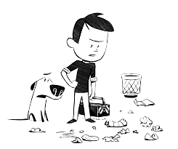

In our town, there is a problem with litter in the streets. People throw trash everywhere, making our community dirty. To solve this, we can organize a clean-up day where everyone helps pick up garbage. We can also put more trash bins on the streets. Together, we can keep our town clean!

51.-What is the problem in the town?  - Not enough garbage.  - Too much rain.  C) Trash on the streets. | 52.-How does litter affect the community?  - Makes everyone happy.  - Makes more friends.  - Makes the town dirty. | 53.-What can everyone do to help solve the problem?  - Ignore the litter.  - Throw more trash.  - Help pick up garbage.

A Mexican celebration
Each country has a culture with many beautiful and interesting characteristics which are admired by other countries. It is important to know about the customs of our country in order to show them to other people.
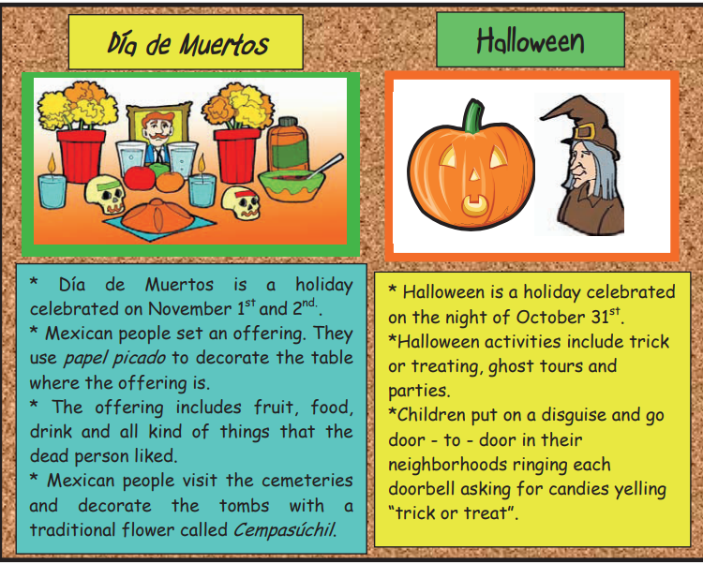
Write the mainly characteristics of both celebrations.
Día de Muertos | Halloween

Give 5 advice in order to maintain a good health, write the imperative form, for example:
- Don’t eat junk food

Choose the correct answer
1.- We cook / cooks dinner.
2.- My aunt drives / drive the car.
3.- I read / reads a comic.
4.-They sleep / sleeps.
5.- You study / studies.
Complete the past of the verbs.
INFINITIVE | PAST | INFINITIVE | PAST | INFINITIVE | PAST
Write |  | Study |  | Have
Live |  | Speak |  | Like
Eat |  | Do |  | Play
Go |  | Sleep |  | Drink
Drive |  | Clean |  | Read
Run |  | Swim |  | speak

Write the comparative and superlative adjective correctly
Adjective | Comparative
Good
Nice
Cheap
Expensive
Bad
Big
Tall
Pretty
Fast
Happy
Small
Sad
Boring

Choose the correct comparative or superlative to each sentence.
16.-Azucena is __________ than Amanda ( more taller - taller)
17.--U.S.A is __________ than Mexico (colder- less colder)
18.--My computer is ________ than yours. (cheapest - cheaper)
19.-.-I´m the ______ person in my class. (tallest - taller)
20.-My dog is my ________ friend. ( best - better)

ORDER THE WORDS TO MAKE SENTENCES IN THE FUTURE TIME.

1.GO / NEXT / PEDRO / MOVIES / THE/ WEEKEND/ IS GOING TO
________________________________________________
2.-FEED/ DOG/ PACO / HIS / TOMORROW / IS GOING TO
___________________________________________
3.-FOR / EXAM / I / WILL / MY / NEXT WEEK /STUDY
_________________________________________
Fill in the sentences with the correct form (past simple OR future plans ) of the verbs in parentheses.

1. I ________________ (play) tennis last Saturday.
2. My brother __________________ (wash) his car next Friday.
3. Mom __________________ (cook) rice for the lunch next week .
4. Yesterday I __________________ (study) English all evening.
5. I _______________(eat) Italian food last night.
6. I ________________ go) to a concert last weekend.

